CITI Training Information
CITI training provides a Social Behavioral Research for Students Course and a Responsible Conduct of Research for Social and Behavioral Science Doctoral Learners Course (RCR), both focusing on research ethics and fundamentals of conducting research with human subjects. A variety of topics are covered to help you design your study so that you are conducting ethical, safe, and valid research.
CITI training is a prerequisite of GCU IRB approval. IRB approval is required before conducting research of any kind. You can take CITI training any time. CITI training consists of online modules that are self-paced. The modules take approximately 15 hours to complete, and the training is free to GCU doctoral learners and faculty.
When you complete the two CITI courses, you will have a certificate of completion for each course, valid for 5 years. After you complete CITI training, keep a copy of your two CITI completion reports (Social Behavioral Research, and RCR). The current IRB submission system, iRIS, will automatically pull in your CITI reports to your IRB application package; however, we suggest keeping a copy of the completion reports in your files.
CITI Home Page
https://about.citiprogram.org/en/homepage/
To register for CITI training:
1. Go to www.citiprogram.org
2. Click “Register”
3. Select Grand Canyon University from the list of “Participating Institutions”, leaving the other fields blank.
4. Type in personal information. Enter your first and last names, verify your email address, and fill out gender and race section. To ensure appropriate linkage with your IRB application, Please use your GCU email address not your personal email address.

5. Create a username and password, and choose security questions.
6. Select “Yes” or “No” for CME/CEU credits (*GCU students will typically select No unless Continuing Medical Education or Continuing Education credit is desired).
- Select “Yes” or “No” for voluntarily completing a research survey.
- Click “continue” to proceed to next step.
7. Enter Learner Registration. Required fields are marked by an asterisk (*).
- For Institutional Email Address, enter your GCU email. Your GCU email is your username@my.gcu.edu. If you are unsure what your email is, please contact Technical Support at support.gcu.edu. This step is critical in ensuring your CITI records are linked to your IRB application.
- If you do not know your Student ID number please enter 0 or contact Technical Support for assistance.
- For *Role in Human Subjects Research, select Student Researcher – Graduate level
- For *Which course do you plan to take? Select Social and Behavioral Research for students.
- Complete the remaining fields indicated as required by the *Symbol.
8. Click “continue” to proceed to Select Curriculum Section
- Question #1 ALL LEARNERS MUST select “Yes, I am a student conducting no more than minimal risk research”. This indicated whether the study falls under Exempt, Expedited, or Full Review.
- Question #2 select “Yes,” I am required to complete the RCR for Social and Behavioral Science Doctoral Learners
9. Click “Complete Registration” then click “Finalize registration”. Click on drop down menu next to Grand Canyon University Courses.
10. You will be enrolled in two courses:
• RCR FOR SOCIAL AND BEHAVIORAL SCIENCE DOCTORAL LEARNERS. To pass this course you must complete the 5 required modules.
• SOCIAL BEHAVIORAL RESEARCH FOR STUDENTS (Basic Course). To pass this course you must complete all 19 required modules.
11. The following screen will appear once you log in (see screen shot below).
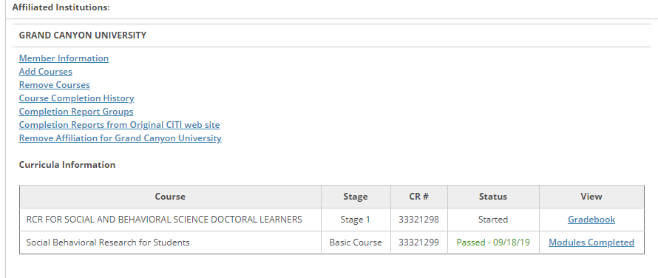
12. Select the title RCR FOR SOCIAL AND BEHAVIORAL SCIENCE DOCTORAL LEARNERS, to start course. Click on The Integrity Assurance Statement before beginning the course.
After reading and signing the Integrity Assurance Statement access is granted to complete the 5 required modules. Note: After you have started the course, you can complete the modules at your own pace by logging back in to access course(s). You do not have to complete all modules in the course at one time.
13. Then select the title SOCIAL BEHAVIORAL RESEARCH FOR STUDENTS to start next course. Click on The Integrity Assurance Statement before beginning the course. After reading and signing the Integrity Assurance Statement access is granted to complete the nineteen (19) required modules. Note: After you have started the course you can complete the modules at your own pace by logging back in to access course(s). You do not have to complete all modules in the course at one time.

