How to access and share documents using Microsoft Office Online
Start by logging into your my.gcu.edu email through the student portal.
You may also access the SkyDrive with any Hotmail or Windows Live account.

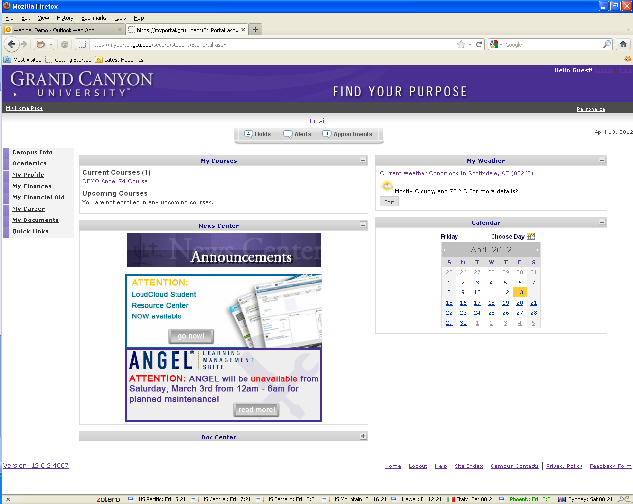

Click on the Email the link in the box as shown below.
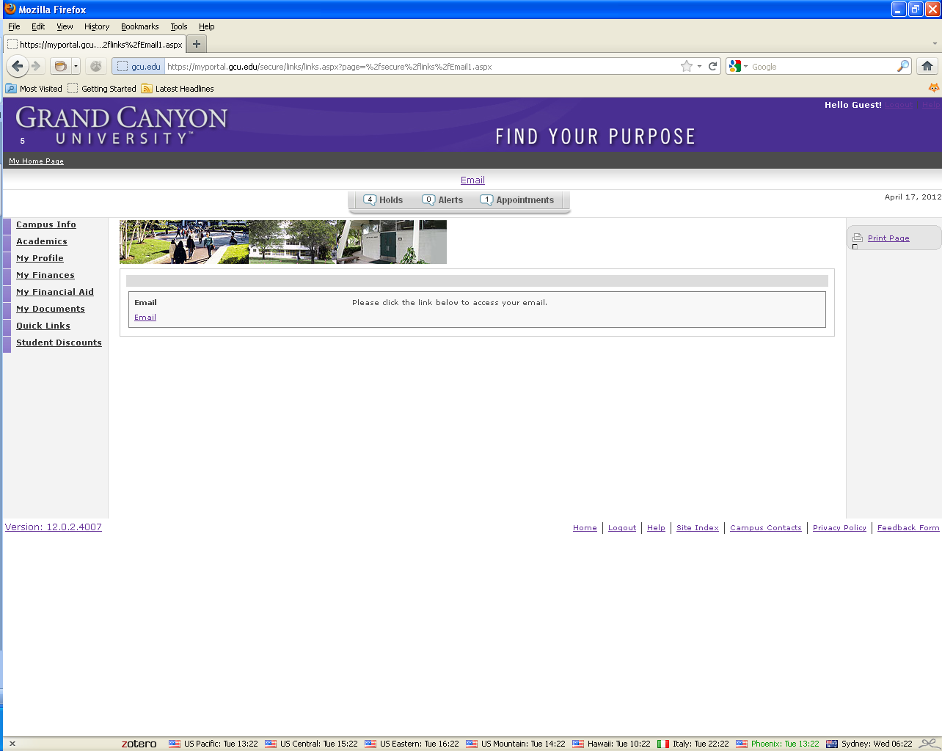

Now that you have logged into your email, click on the Office link at the top of your screen, if you get a drop down menu click on Your Documents.
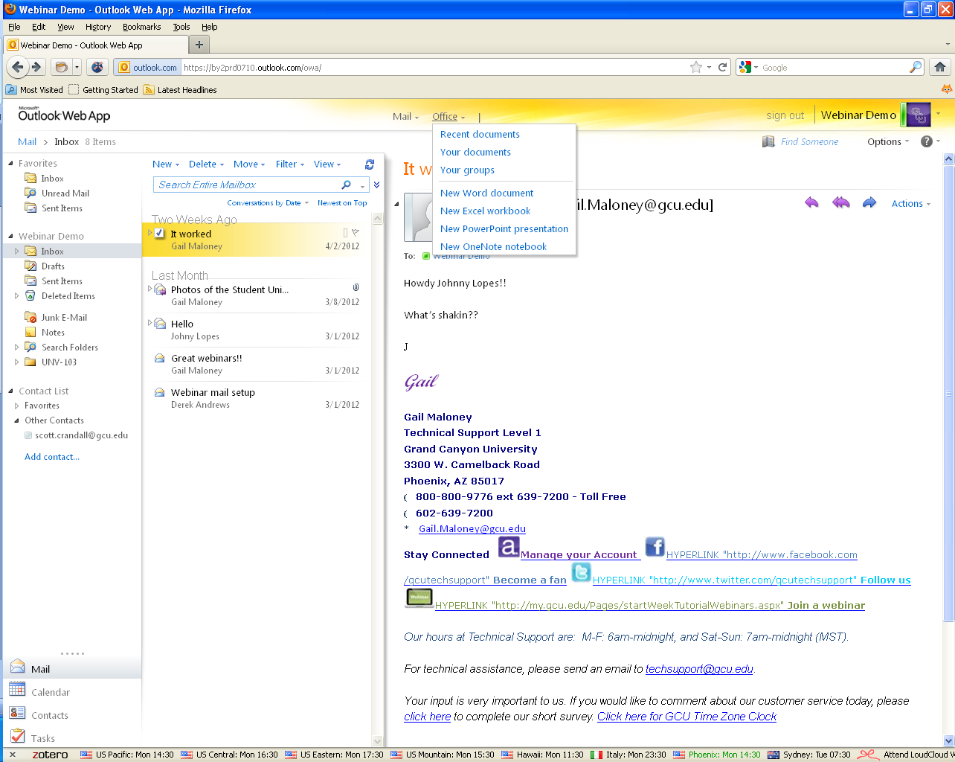

From the SkyDrive page click on Shared Documents to view all documents that have been shared with you.
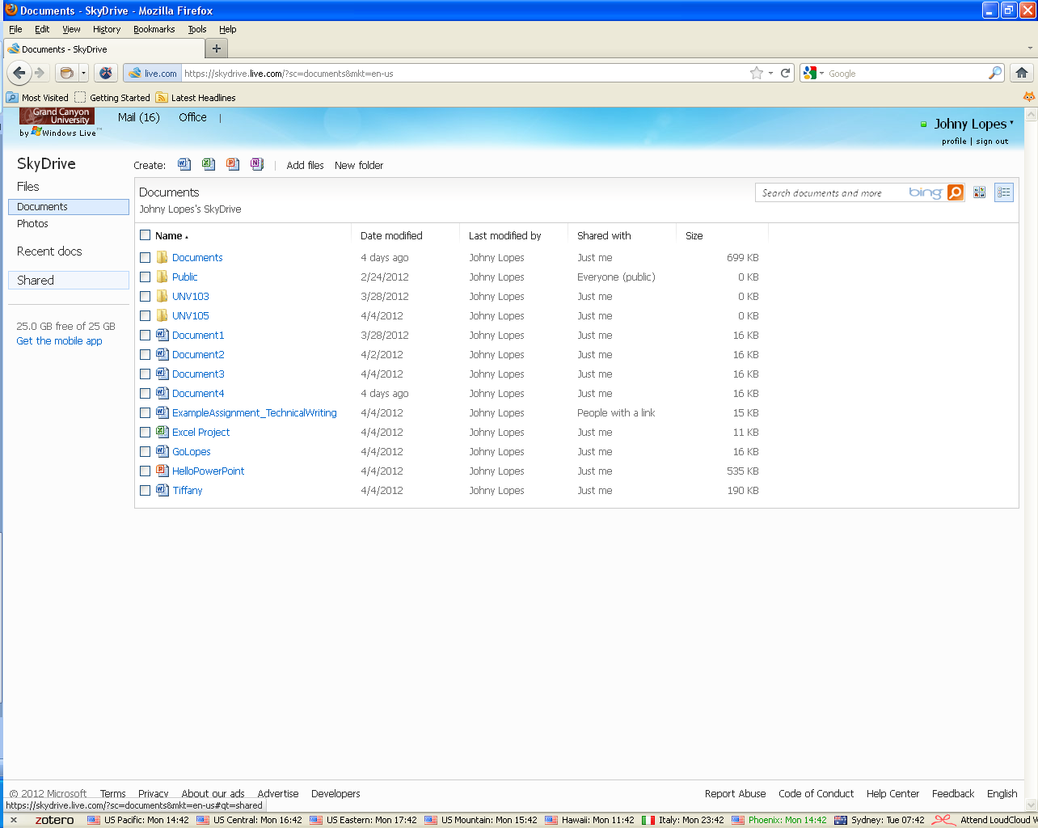

Click on the document you would like to view.

To edit the document, click on Edit in Browser.
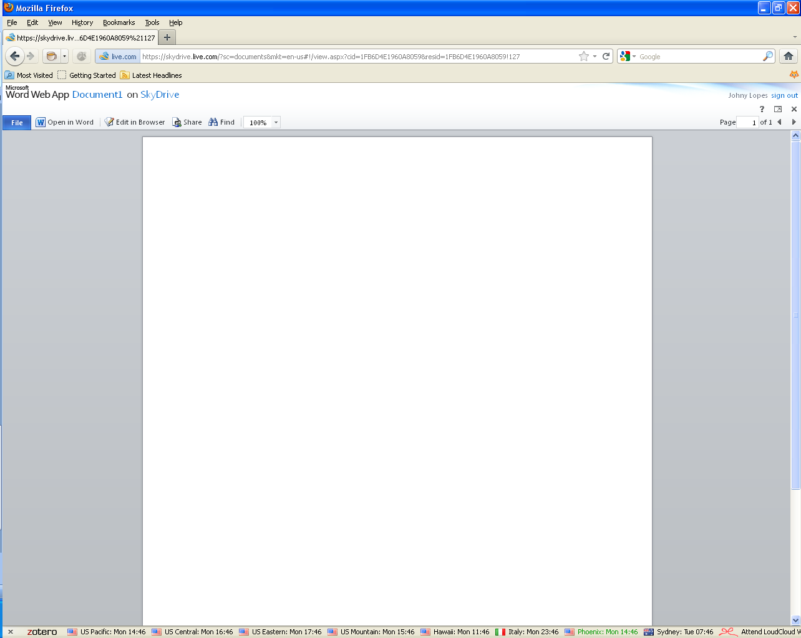

Once an edit to the document has been made, click on file then save or the disc icon to save the document. Everyone will need to refresh their screens to see the updates.
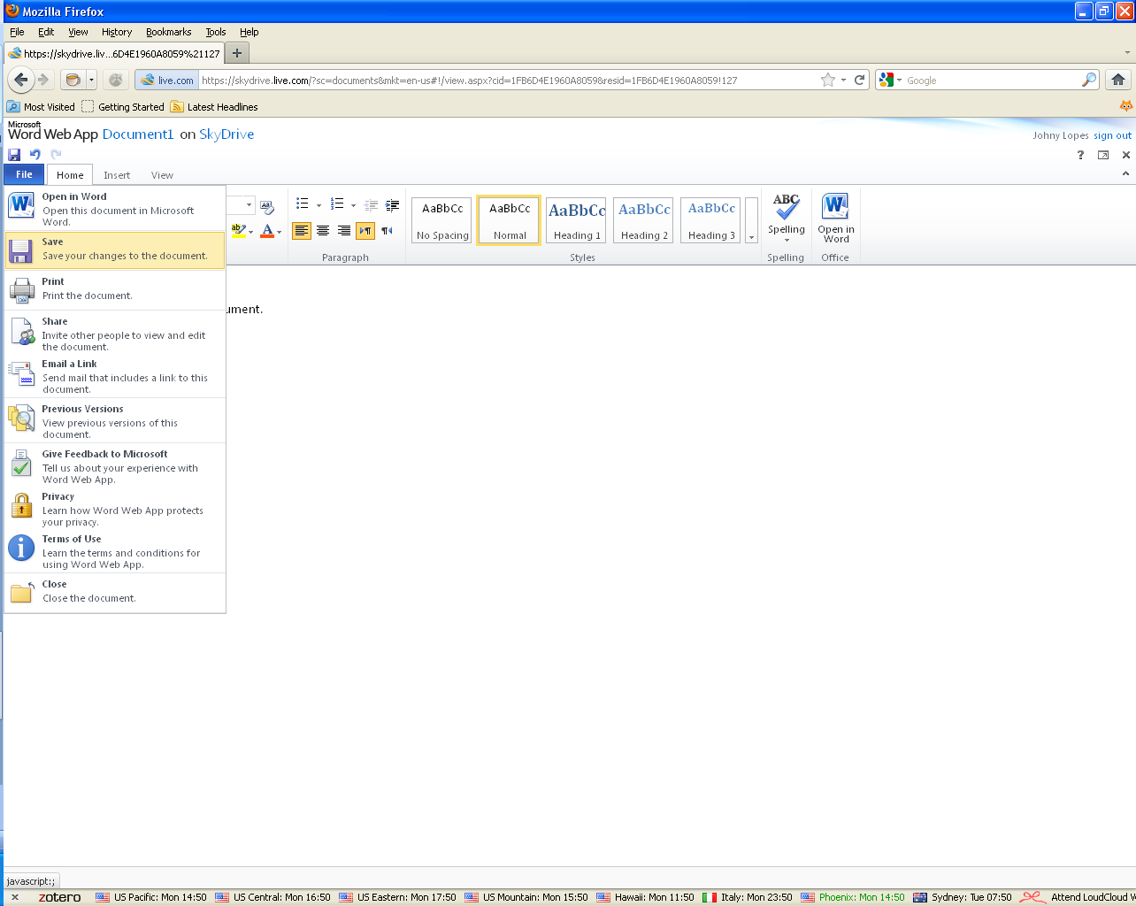

To create a Word document using Office Online, click on the Word icon.

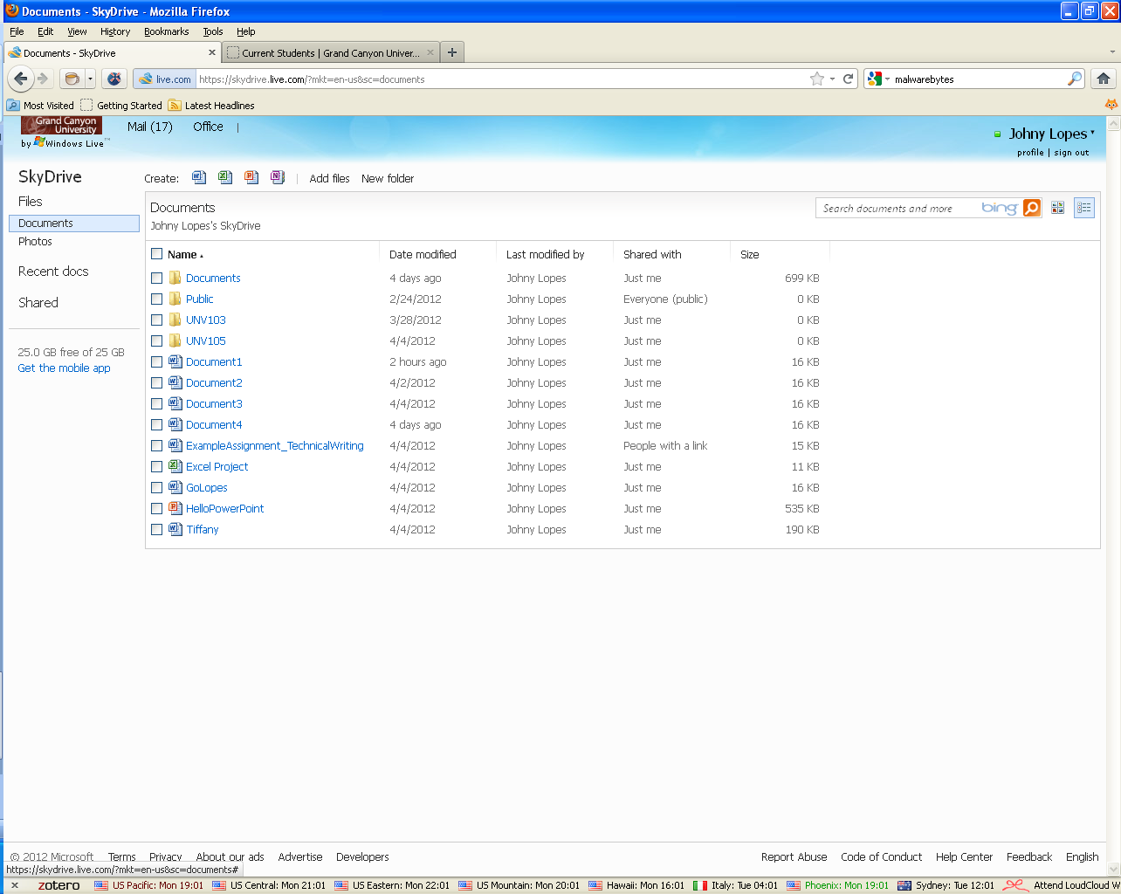

To share a saved document, click on the box to the left of the document’s name and then share from the menu on the right.
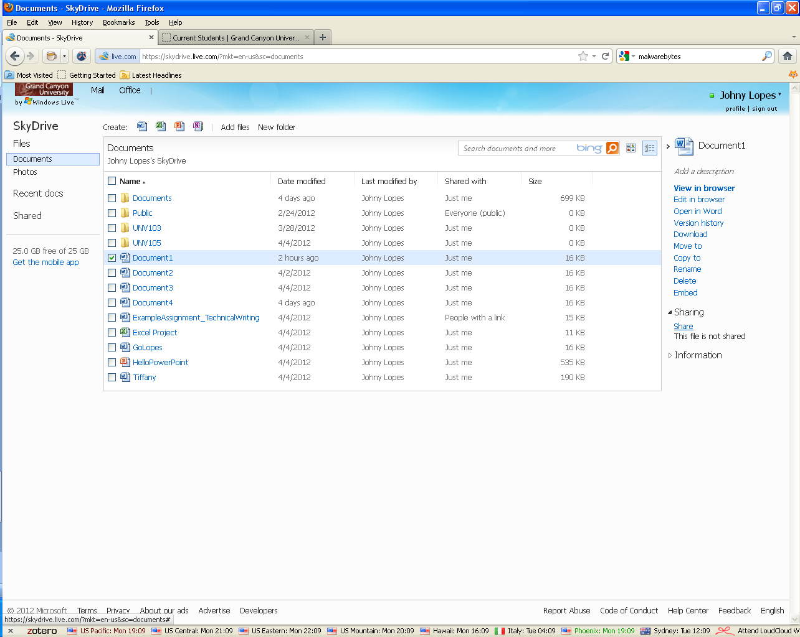
Now enter the email address of the people you would like to share the document with.
To learn more please join the Microsoft Office Online and SkyDrive webinar.
http://www.gcu.edu/Student-Life/Technical-Support/Student-Success-Webinar.php
For further assistance, please visit our Tech Support page.
http://www.gcu.edu/Student-Life/Technical-Support.php

